ATM ANALYSIS

The external interface requirements of ATM system:

1. User interfaces

The interface of the ATM must fulfill ergonomic requirements. The following is just an example for a possible interface to the ATM

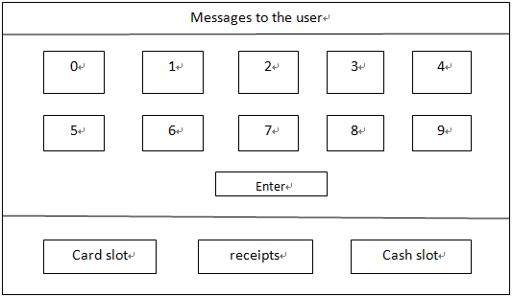

1. Hardware Interfaces

The ATM network has to provide hardware interfaces to:

1. Various printers
2. Various ATM machines (There are several companies producing the ATM machines.)
3. Several types of networks The exact specification of the hardware interfaces is not part of this document.
4. Software interfaces

The ATM network has to provide software interfaces to:

1. The software used by different banks
2. Different network software

The exact, detailed specification of the software interfaces is not part of this document.

1. Communication Interfaces

There is no restriction of the ATM network to a specific network protocol as long as the performance requirements are satisfied.